Shell Scripts

1.

2.

3.

4.

5.

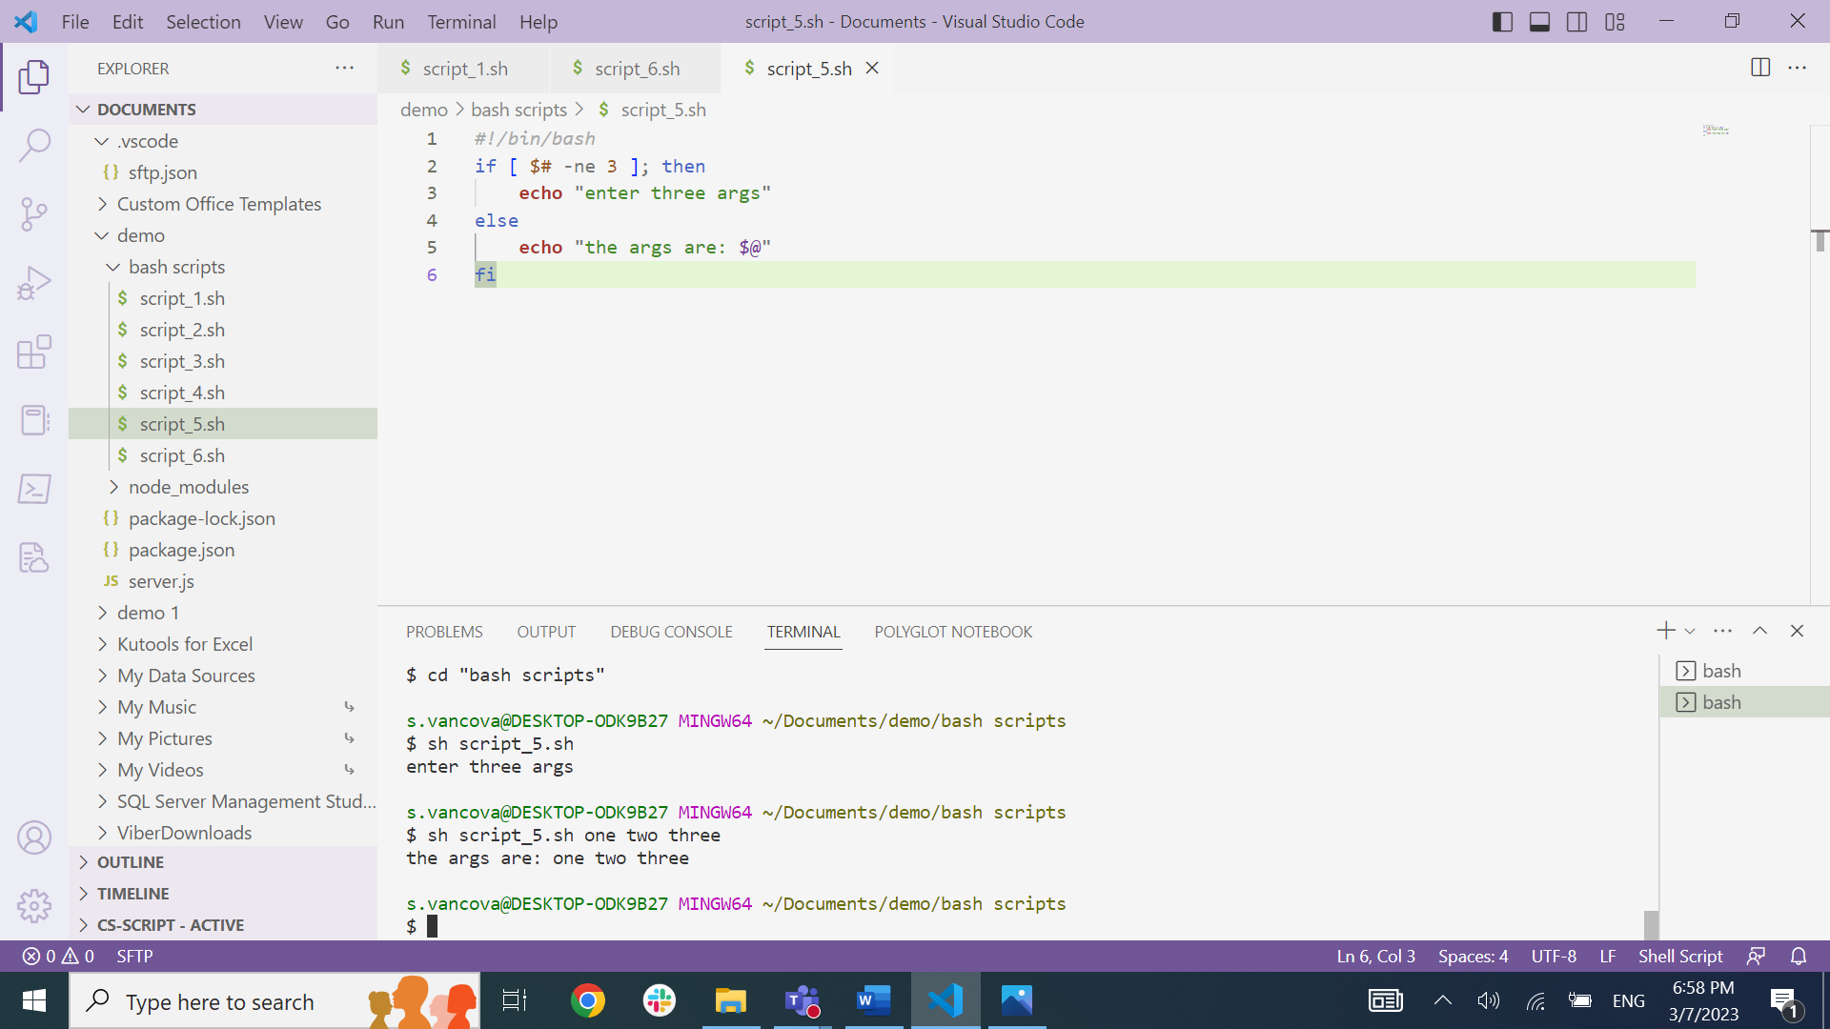

6.

\*I tried using the uptime command but I didn’t print any output (I think is because I run bash on windows). So I tried this systeminfo command.